A dog will eat one can of dog food each day.

Monday | Tuesday | Wednesday | Thursday | Friday | Saturday | Sunday


One can of food costs:

How much does it cost to feed a dog for one day?

How many days are there in a week?

How much does it costs to feed one dog for a week?
Monday | Tuesday | Wednesday | Thursday | Friday | Saturday | Sunday

____+______+_____+_____+_____+_____+____ = ____

_____ x _____ = ____

It costs ________ to feed one dog for one week.
Calculator Exercises

How many days are there in this month?

How much does it cost to feed a dog for a month?

_____ x _____ = ____

How many weeks are there in a year?

How much does it cost to feed a dog for a year?

_____ x _____ = ____

How much does it cost to feed TWO dogs for a year?
_____ x _____ = ____


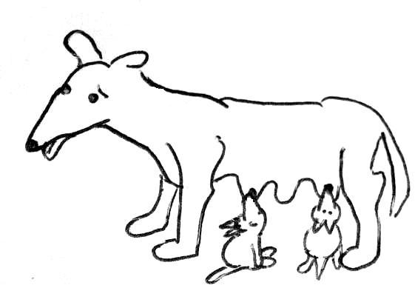
How many puppies does Gudaga have?

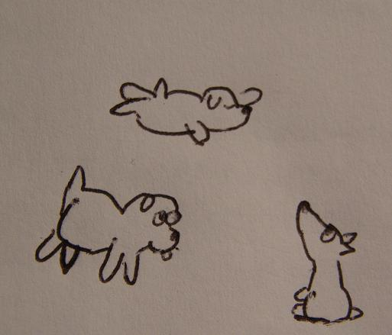
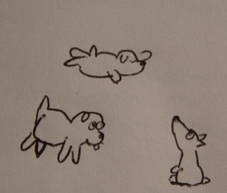
20


When the puppies grow up, they each have five puppies.
20

Count how many puppies there are now.
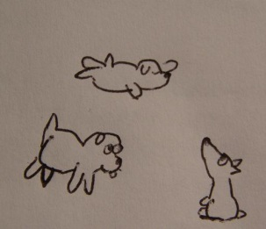
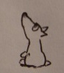



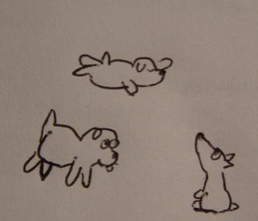

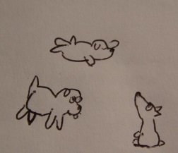







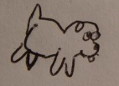

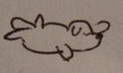
Five cousins come over
to help look after the puppies

How many puppies does each cousin need to look after?
25 ÷ 5 = _____
Cut out the puppies and give them to the cousins
so that every cousin has the same number of puppies to look after.

Uncle has brought home
some bones
for the puppies.
Count how many bones
he has brought.

Cut out all the bones.
Give the bones to the cousins
so that every cousin has
the same number of bones.
How many bones
does each cousin get?

Auntie has bought
some cans of dog food
for the puppies.
Count how many cans
she has brought.

Cut out all the cans.
Give the cans to the cousins
so that every cousin has
the same number of cans.
How many cans
does each cousin end up with?

